
Available online at www.sciencedirect.com
SCIENCE tft) DIRECT
Computer Communications 28 (2005) 898-907

www.elsevier.com/locate/comcom
Integrating connectionless and connection-oriented traffic using
quantum packets
Ray Y.W. Lamª, Henry C.B. Chanª*, Tharam S. Dillon^{b}, Victor O.K. Li^{c}, Victor C.M. Leung^Department of Computing, The Hong Kong Polytechnic University, Hung Hom, Kowloon, Hong Kong Faculty of Information Technology, The University of Technology Sydney, NSW, Australia ^{d}
^{c}Department ofElectrical and Electronic Engineering, The University ofHong Kong, Pokfulam Road, Hong Kong ^{d}Department ofElectrical and Computer Engineering, The University ofBritish Columbia, Vancouver, BC, Canada
Received 12 August 2003; revised 23 November 2004; accepted 24 November 2004 Available online 10 December 2004
Abstract
Recently, integrating connectionless (CL) and connection-oriented (CO) traffic has been of considerable interest. While CO traffic is often transferred by asynchronous transfer mode (ATM), it is preferable to use multiprotocol label switching (MPLS) for CL traffic. To packetize CL and CO traffic flexibly and efficiently, we propose a general packetization mechanism, the 'quantum packet' method. In view of the increasing need to integrate CL and CO traffic, we use a Markov model to analyze the packet loss ratio and the average packet transfer delay when these two types of traffic are integrated under three multiplexing schemes. The results provide us with a better understanding of the behavior of the system, as well as valuable insights into the development of integrated networks. © 2004 Elsevier B.V. All rights reserved.
Keywords: ATM; MPLS; Quantum packets
1. Introduction
Asynchronous transfer mode (ATM) offers a connection-oriented (CO) mechanism to transfer packets of 53 bytes (cells) [1,2] Internet Protocol (IP) packets are transferred using connectionless (CL) networks [2,3]. Integrating the Internet and ATM is of considerable interest (e.g. [4,5]). Methods/specifications have been proposed to enable Internet services over ATM [6-8].
Recently, switching mechanisms have been proposed for enabling IP/CL packets to be transferred using label switching [9-11]. Multiprotocol label switching (MPLS) was subsequently created [2,12,13]. Furthermore, researchers of the Advanced Communications Technologies and Services programme have worked on projects about
integrating IP and ATM [14], such as IthACI [5]. Other works on this subject include dual-mode routing [15,16] and A/I Net [4]. We believe that, inspired by other similar
* Corresponding author. Tel.: C852 2766 7269; fax: C852 2774 0842. E-mail address: cshchan@comp.polyu.edu.hk (H.C.B. Chan).
projects, integrating the Internet, ATM, and active networks will lead to the creation of an advanced network (ISDN3) [17].
In this paper, we consider the integration of CL (IP/MPLS) and CO (ATM) traffic for the above projects. IP/MPLS traffic is packetized using either the ATM Adaptation Layer (AAL) [1,2] (AAL5 [18] preferred) or a quantum packet method. The quantum packet method is similar to AAL, except that the packetization efficiency for CL traffic can be improved. As will be explained later in greater detail, the quantum packet method can also be viewed as a general packetization mechanism (i.e., it is for both IP/MPLS and ATM traffic). In fact, the AAL packetization method can become a special case of the quantum packet method. Although many studies have analyzed the performance of multiplexing ATM/CO traffic (e.g. [19,20]), relatively little work has been done on integrating CL and CO traffic. To contribute to this issue, this paper presents a Markov model that can be used to evaluate the average delay in the transferring of data and the probability of loss of data when both types of traffic are integrated under three schemes.
The rest of the paper is organized as follows. In Section 2, we give an overview of quantum packets. In Section 3, we present the analytical/Markov model that is used to evaluate the performance of the three schemes for multiplexing CL and CO traffic. In Section 4, we discuss the analytical and simulation results. In Section 5, we present the conclusions of the paper.
2. Overview of quantum packets
This section gives an overview of quantum packets. 'Quantumization' is the process for creating quantum packets. It can be viewed as an extended AAL process [1,2]. As shown in Fig. 1, a quantum packet has one or more quanta (53 bytes). A packet header, PH, and trailer, PT, may be attached. A quantum header, QH, and trailer, QT, may also be added. The 1-byte quantum label (similar to a cell header) has the TYPE (e.g., IP/MPLS packets or ATM cells), END, SYN (Synchronization), and PRI (Priority) bits [17]. The END bit of the last quantum and other quanta has a value of one and zero, respectively. Similar to VC-merging [4,9], quantum packets of various types can be transferred using type-merging, i.e., interleaving quanta associated with two or more quantum packets of the identical type, and priority is not allowed.
As mentioned in Section 1, it is preferable to use the AAL5 [18] packetization method for CL (IP/MPLS) traffic.
In fact, AAL5 can become a special case of the quantumization process. No PH is required and the PT is the AAL5 Convergence Sublayer Protocol Data Unit (CS-PDU) trailer. Furthermore, a quantum is formed from an ATM cell. The first byte of the cell header serves as the quantum label, which should be feasible.
As shown in Fig. 1, it is possible to quantumize an IP/ MPLS packet more efficiently. An eight-byte PT and padding bits are added. It is then divided into 52-byte units. No QH or QT is attached. Finally, the quanta are created by adding the one-byte quantum label to each unit. Again, similar to VC-merging [4,9], the quanta of a quantum packet must be transferred with type-merging. The PT is similar to the one used in AAL5. No PH is required because the complete quantum packet is transferred using the MPLS header.
The above quantum packet method can also be used for CO traffic. As shown in Fig. 1, a quantum packet with one quantum can be formed from an ATM cell. Similar to the above, the first byte of the cell header serves as the quantum label. The END bit of the quantum label has a value of one.
3. Model
In this section, we present a Markov model [21] that will be used to analyze the transfer delay and packet loss ratio at a node when two types of traffic, namely CL traffic
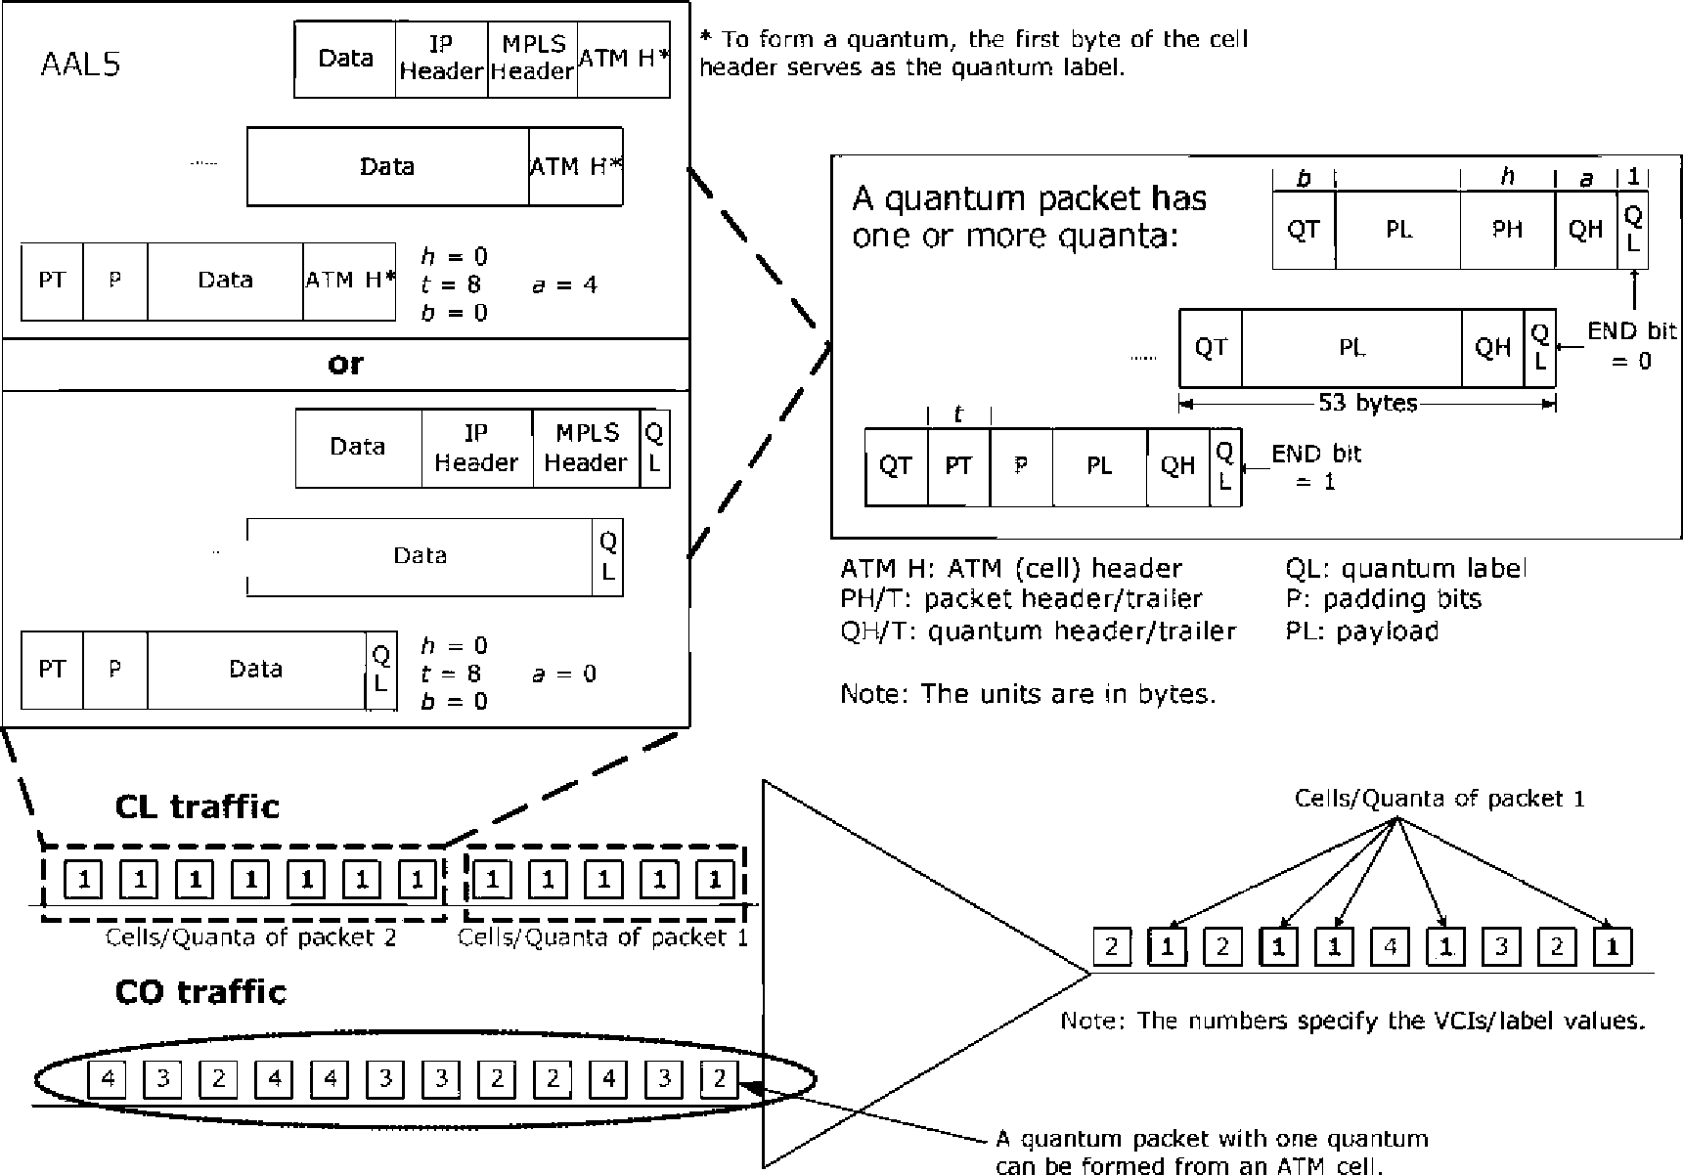
Fig. 1. Multiplexing of CL and CO traffic.
(e.g. IP/MPLS traffic) and CO traffic (e.g. ATM traffic), are integrated. As discussed above, a quantum packet with one quantum can be formed from an ATM cell. The CL traffic can be packetized using the proposed quantum packet method as described in Section 2. Recall that a quantum packet has one or more quanta. The quanta of a quantum packet must be transferred with the type-merging mechanism. In the following analysis, we consider a general scenario using discrete data units (cells/quanta), i.e. the analysis applies to both the proposed quantum packet method and the ATM packetization method (e.g. using
AAL5 [18]).
We consider that a CO packet has one cell/quantum and a CL packet has m cells/quanta. The former and latter traffic are sensitive to time and loss, respectively. A node has two separate buffers, namely the CO buffer (COB) and the CL buffer (CLB), which are used to hold the CO packets and the CL packets. A buffer can hold s CO packets or s/m CL packets. We assume that s/m is an integer. To perform the analysis, we also assume a model with discrete time. At time t, the state of the system is defined as (COB_{t}, CLB_{t}), where COB_{t}, and CLB_{t} specify the number of cells/quanta respectively in the CO and CL data buffers at time t.
Also, k new CO packets arrive or a new CL packet with m cells/quanta arrives with a probability of P_{co} or P_{cl}, respectively, where both k and m are not greater than s.
The aim of the analysis is to evaluate the average transfer delay and the packet loss ratio under the following schemes.
Scheme 1: CO traffic has a non-preemptive priority over CL traffic. This means that whenever a CO packet arrives it will wait until the current CL packet completes its transmission. A new CL packet will not be transferred unless the CO packet buffer is empty. Scheme 2: CO traffic has preemptive priority over CL traffic. Whenever a CO packet arrives, the current CL packet transmission will be terminated and the transferred cells/quanta of the CL packet will be lost, i.e. when the CO packet buffer is empty, the CL packet is transferred again.
Scheme 3: CO traffic has preemptive priority over CL traffic, as in Scheme 2, except that the transferred cells/quanta of the CL packet will not be lost.
Fig. 2 shows an example that illustrates the status of the buffers for the three schemes in the following scenario.
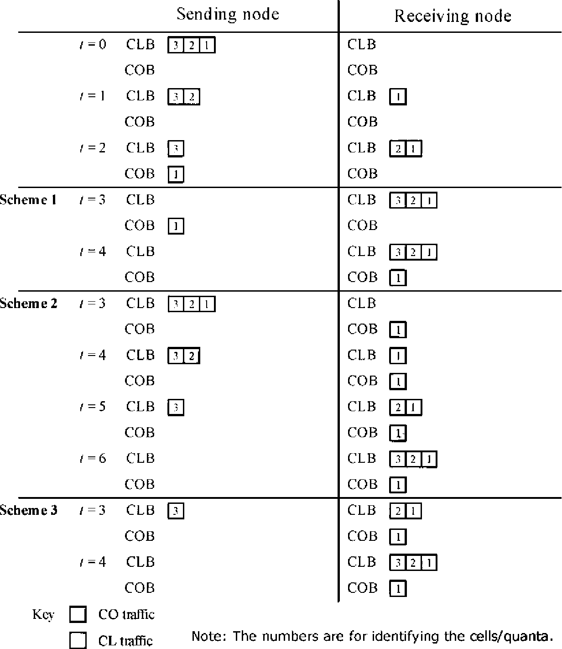
Fig. 2. An example illustrating the three schemes.
Both COB and CLB are initially empty. Suppose that a CL packet with 3 cells/quanta arrives at t = 0. Cells/quanta 1 and 2 are transferred at t= 1 and 2, respectively. At t = 2, a CO packet arrives at COB. In Scheme 1, the CO packet must wait for cell/quantum 3 to finish before it can be transferred at t= 4. In Scheme 2, the CO packet preempts the CL packet at t= 3. The transferred cells/quanta 1 and 2 are lost at the receiver. The complete CL packet is transferred again, starting at t= 4. In Scheme 3, the CO packet preempts the CL packet at t= 3 in the same way. However, at t= 4, only cell/quantum 3, is transferred.
The transition probabilities, P(COB_{tC1}, CLB_{t+1}\COB_{t}, CLBt), from the current state, (COBt, CLBt), at time t to the next state, (COB_{tC1}, CLB_{tC1}), at time tC1 for the three schemes are given in Table 1. We have four possibilities with respect to the arrival of new CL packets and CO packets at the time slot between time t and tC1, as follows:
1. With a probability of P_{co}P_{cl}, both k CO packets and a CL packet with m cells/quanta arrive at the same time.
2. With a probability of P_{co}(1— P_{cl}), only k CO packets arrive.
3. With a probability of (1 — P_{co})P_{cl}, only a CL packet arrives.
4. With a probability of (1 — Pco)(1— Pcl), no CO packet or
CL packet arrives.
Referring to Table 1, the cases for Scheme 1 are explained as follows.
Case A Both COB and CLB are empty at time t.Ifk CO
packets arrive, COB_{tC1} becomes k. Similarly, if a CL packet arrives, CLBtC1 becomes m.
Case B At time t, COB is empty but CLB is not. Also, CLB can hold the m cells/quanta of a new CL packet. One cell/quantum in CLB is transferred to the receiver, so one is subtracted from CLB_{tC1}. Again, k and m are added to COB_{tC1} and CLB_{tC1}, respectively, when new CO packets and a new CL packet arrive.
Case C Both COB and CLB are not empty at time t. If the remainder of CLBt/m (i.e., CLBt mod m) is not equal to zero (i.e. a CL packet is in transmission), CO traffic must wait until the current CL packet has finished the transmission (i.e. when CLB_{t} mod m= 0). The calculations for COB_{tC1} and CLB_{tC1} are the same as in case B. Note that, when COB cannot hold the k new CO packets, some CO packets are lost. Therefore, COB_{tC1} is min{COB_{t-}Ck, s}, where min{x, y} gives the minimum value of x and y.
Case D This is similar to case B, except that CLB cannot hold the m cells/quanta of a new CL packet at time t (since CLB_{t}>s — m). When a CL packet arrives, it is lost and no cell/quantum is added to
CLB.
Case E This is similar to case C, except that, here, CLB cannot hold the m cells/quanta of a new CL packet at time t. The calculations for COB_{tC1} and CLB_{tC1} are the same as in case D. Note that a CL packet in transmission implies that s> CLB_{t}>s — m, since s is divisible by m.
Case F At time t, CLB is empty while COB is not. One CO packet in COB is transferred to the receiver and one is subtracted from COB_{tC1}.
Case G Neither COB nor CLB is empty. No CL packet is in transmission (since CLB_{t} mod m= 0). Therefore, priority is given to CO raffic and one CO packet is transferred to the receiver from COB.
Case H CLB is full. This implies that no CL packet is in transmission since s mod m = 0. Hence, CO traffic is served.
Case I This is similar to case F, except that COB is full at time t. One CO packet in COB is transferred to the receiver and the new CO packets are lost.
Case J This is similar to case G, except that COB is full at time t. One CO packet in COB is transferred to the receiver and the new CO packets are lost. Case K This is similar to case C in that a CL packet is in transmission. However, COB is full at time t.A cell/quantum from CLB is transferred. The new CO packets are lost. Case L This is similar to case K, except that CLB cannot hold the m cells/quanta of a new CL packet. The new CO packets are not added to COB nor is the CL packet added to CLB. A cell/quantum from CLB is transferred.
Case M Both COB and CLB are full at time t. Therefore, a
CO packet from COB is transferred. Again, the new CO packets and CL packet are lost. Case N If none of the above cases applies, the transition probability is 0.
TI_{xy/}The transition probabilities for Schemes 2 and 3 can also be calculated. In fact, many cases are the same as those for Scheme 1. Hence, we only include the differences in Table 1 (as explained below). Under Scheme 2, we see only a difference in those cases in which a CL packet is in transmission (i.e., Cases C, E, K and L), while COB is not empty. In those cases, CO traffic preempts CL traffic and the CL packet in transmission must be transferred again. Therefore, one is subtracted from COB_{tC} ₁,whereas CLB_{tC1} is incremented by m— CLB_{t} mod m. Similarly, under Scheme 3, CO traffic can preempt CL traffic in cases C, E, K, and L. However, it is not necessary to add m— CLB_{t} mod m to CLB_{tC1}. We denote the stationary probabilities by n_{i}j,where i and j are, respectively, the number of cells/quanta in COB and CLB. They can be found by using the following equations [21]:
s s
Pxy = J2J2 ^{n}ijP⁽x> y\i; jj (1)
i=0 j=0
Table 1
Transition probabilities for Schemes 1-3
Scheme 1:
Cases COB, | CLB, | COB,₊ 1 | ^{CLB}tC 1 | P(COB,₊1, CLB,₊ i\
 |  |  |  | COB,, CLB,)
A 0 | 0 | 0 | 0
 |  | k | 0 | Pco (1-Pcl)
 |  | 0 | m | (1 -P_{co}) P_{cl}
 |  | k | m | P P
B0 | s-m>CLB_{t}>0 | COB, | CLB,- 1 | (1-Pco)(1-Pcl)
 |  | min{COB,+k, s} | CLB,- 1 | Pco (1-Pcl)
C s>COB_{t}>0 | s-m>CLB_{t}>0 and | COB, | CLB,Cm- 1 | (1 -Pco) Pcl
 | CLB, mod m> 0 | min{COB,Ck, s} | CLB,Cm- 1 | _{PP}  ^{P}co ^{P}cl
DO | CLB,> s- m | COB, | CLB,- 1 | 1-Pco
E s>COB_{t}>0 | CLB,> s- m and | min{COB,Ck, s} | CLB,- 1 | P  co
 | CLB, mod m> 0
F s>COB_{t}>0 0 |  | COB,- 1 | CLB, | (1-Pco)(1-Pcl)
 |  | min{COB,Ck, s}- 1 | CLB, | Pco (1-Pcl)
G s>COB_{t}>0 | s- m> CLB,> 0 and | COB,- 1 | CLB,Cm | (1 -Pco) Pcl
 | CLB_{t} mod m = 0 | min{COB,Ck, s}- 1 | CLB,Cm | ^{P}co ^{P}cl
H s>COB_{t}>0 | s | COB,- 1 | s | 1-Pco
 |  | min{COB,Ck, s}- 1 | s | _{P}  co
I s | 0 | s- 1 | CLB, | 1-Pcl
J s | s- m> CLB,> 0 and | s- 1 | CLB,Cm | Pcl
 | CLB, mod m= 0
K s | s- m> CLB,> 0 and | s | CLB,- 1 | 1-Pcl
 | CLB, mod m> 0 | s | CLB,Cm- 1 | ^{P}cl
L s | CLB,> s- m and | s | CLB,- 11
 | CLB, mod m> 0
M s | s | s- 1 | s | 1
N Otherwise |  |  |  | 0
Cases C, E, K, and L of Scheme 2:
Cases COB, | CLB, | COB,₊ 1 | ^{CLB}tC 1 | P(COB,+1, CLB,d\
 |  |  |  | COB,, CLB,)
C s> COB,> 0 | s- m> CLB,> 0 and | COB,- 1 | CLB,Cm- CLB, mod m | (1-Pco)(1-Pcl)
 | CLB, mod m> 0 | min{COB,Ck, s}- 1 | CLB,Cm- CLB, mod m | Pco (1-Pcl)
 |  | COB,- 1 | CLB,C2m- CLB, mod m | (1 -Pco) Pcl
 |  | min{COB,Ck, s}- 1 | CLB,C2m- CLB, mod m | _{PP}  ^{P}co ^{P}cl
E s> COB,> 0 | CLB,> s- m and | COB,- 1 | CLB,Cm- CLB, mod m | 1-Pco
 | CLB, mod m> 0 | min{COB,Ck, s}- 1 | CLB,Cm- CLB, mod m | P  co
Ks | s- m> CLB,> 0 and | s- 1 | CLB,Cm- CLB, mod m | 1-Pcl
 | CLB, mod m> 0 | s- 1 | CLB,C2m- CLB, mod m | ^{P}cl
Ls | CLB,> s- m and | s- 1 | CLB,Cm- CLB, mod m | 1
 | CLB, mod m> 0
Cases C, E, K, and L of Scheme 3:
Cases COB, | CLB, | COB,₊ 1 | ^{CLB}tC 1 | P(COB,+1, CLB,d\
 |  |  |  | COB,, CLB,)
C s> COB,> 0 | s- m> CLB,> 0 and | COB,- 1 | CLB, | (1-Pco)(1-Pcl)
 | CLB, mod m> 0 | min{COB,Ck, s}- 1 | CLB, | Pco (1-Pcl)
 |  | COB,- 1 | CLB,Cm | (1 -Pco) Pcl
 |  | min{COB,Ck, s}- 1 | CLB,Cm | ^{P}co ^{P}cl
E s> COB,> 0 | CLB,> s- m and | COB,- 1 | CLB, | 1-Pco
 | CLB, mod m> 0 | min{COB,Ck, s}- 1 | CLB, | P  co
Ks | s- m> CLB,> 0 and | s- 1 | CLB, | 1-Pco
 | CLB, mod m> 0 | s- 1 | CLB,Cm | P  co
Ls | CLB,> s- m and | s- 1 | CLB, | 1
 | CLB, mod m> 0
The average number of CO packets in the system is
E E p.v (3)
and the average number of CL packets in the system is
Note that a CL packet is still considered to be in the originating buffer unless its m cells/quanta are transferred. By using the well-known Little's formula (e.g. see [21]), we can find the average transfer delay, TD_{co} and TD_{cl}, for CO and CL traffic respectively as follows:
^{TD}co = y- E E^{/p}v ⁽⁵⁾
^{Aco} f=0 j=0
where y_{co} and y_{cl} are, respectively, the effective CO packet and CL packet arrival rates, as given below:
^{y}co = (EE^{p}y + E E^⁻ \/=0 j=0 /=s-k+1 j=0 ⁽⁷⁾
^{k} /
s s-m
icl = EE PyPcl (8)
= 0 ■= 0
Note that we need to ignore the CO packets and CL packets that cannot enter the respective buffers because they are full.
Besides the transfer delay, it is also of interest to evaluate the packet loss probability or ratio, which is defined as the probability that an arrived CO packet or CL packet is lost because the relevant buffer is already full. The CO packet loss ratio for CO traffic is
= s- kC1 ■= 0 If the buffer cannot hold a new CO packet, it is lost. The packet loss ratio for CL traffic is
ss
LRcl = E E p« (10)
= 0 ■= s- mC1
Note that a new CL packet (i.e. its m cells/quanta) is lost if the buffer cannot hold the m cells/quanta.
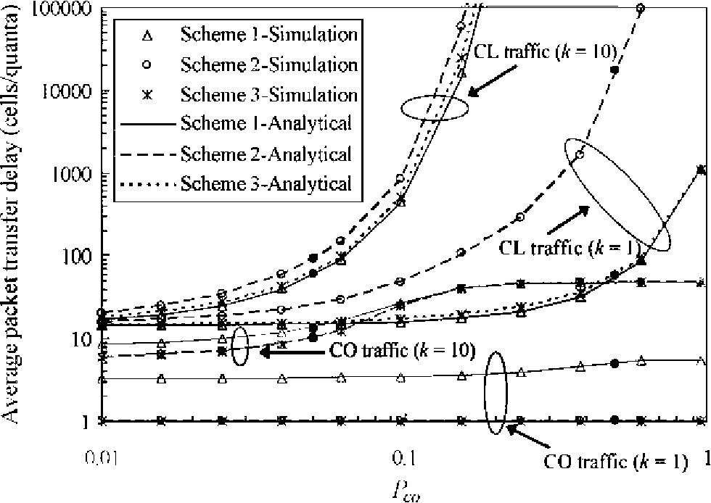
Fig. 3. Average packet transfer delay vs. P_{co}.
4. Results
We here use the Markov model to study the performance of the average transfer delay and packet loss ratio at a single node. The results obtained from the analytical model are validated using results obtained from simulations. To perform the analysis and comparison, we set our base parameters as m= 10, s= 50, P_{co}= 0.05 and P_{cl}= 0.05. These parameters are varied to study their effects on performance.
Figs. 3 and 4 show the average transfer delays and the packet loss ratios, respectively, when the CO packet arrival probability (i.e. P_{co}) is varied. The darker and lighter lines show the results for CL packets and for CO packets, respectively. If we compare the simulation and analytical results, we see that the analytical results are validated by the simulation results. When k= 1, the average CL packet transfer delay is relatively insensitive to a change in P_{co} unless a certain threshold value (about 0.1 in this example) is reached. Furthermore, the delays for both Schemes 1 and 3 are almost the same. The CL packet loss ratios for the three schemes can be kept at a relatively low value until P_{co}
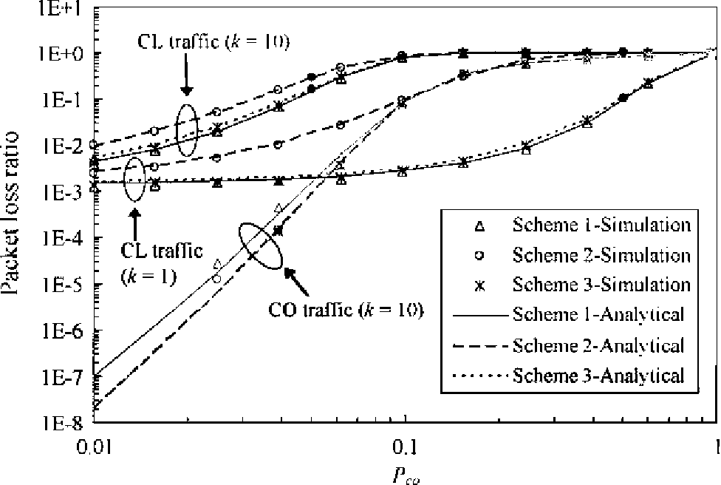
Fig. 4. Packet loss ratio vs. P_{co}.
reaches the threshold value mentioned above. Beyond the threshold, the average CL packet transfer delay and CL packet loss ratio increase more dramatically in Scheme 2 than in Schemes 1 and 3, indicating that the performance of Scheme 2 is more sensitive to a change in P_{co}.
When k= 10, the average CL packet transfer delays and CL packet loss ratios for the three schemes increase more significantly than those when k = 1, particularly when P_{co} goes beyond 0.1. Since the CO packet arrival rate is equal to kX P_{co}, it exceeds the node's processing rate of 1 cell/quantum per unit of time when P_{co}>0.1. The node is always occupied by CO traffic; thus we see a high delay and loss ratio for CL traffic. It is also interesting to examine the effect of the burstiness of CO traffic, k, for a particular CO packet arrival rate. The black dots in Figs. 3 and 4 are the results when the CO packet arrival rate equals 0.5 (i.e., 10X0.05 for k= 10 or 1 X0.5 for k= 1). It can be seen that, for Schemes 1 and 3, the average CL packet transfer delay and the CL packet loss ratio are insensitive to variations in the burstiness of the CO traffic. In Scheme 2, however, the lower the burstiness, the higher the average CL packet transfer delay and the CL packet loss ratio. This is because Scheme 2 does not work well with a high P_{co} (e.g. 0.5 when k= 1), which causes frequent retransmissions of CL packets in Scheme 2.
Regarding the results for CO traffic, the average CO packet transfer delays for Schemes 2 and 3 have a constant value of one when k= 1 because the CO packets have preemptive priority over the CL packets (see Fig. 3). Under Scheme 1, the average CO packet transfer delay remains relatively constant until P_{co} reaches the threshold value of about 0.1. Beyond the threshold, the delay increases towards a maximum value of 5.5. Due to the priority scheme, the CO packet loss ratios are zero for the three schemes.
As shown in Fig. 4, when k= 10, Schemes 2 and 3 have the same CO packet loss ratios, which are lower than that of Scheme 1 in general. The CO packet loss ratios for the three schemes increase towards a maximum value of 0.9 as P_{co} increases. That is, when P_{co}= 1, only one CO packet can be processed for every 10 CO packets that arrive. Below the threshold of 0.1, the average CO packet transfer delays for the three schemes when k= 10 are relatively insensitive to an increase in P_{co}. Similar to the CO packet loss ratio, the average CO packet transfer delay under Scheme 1 is larger than those under Schemes 2 and 3. When P_{co} goes above the threshold value, the CO packet delays for the three schemes increase steeply towards a maximum value of 50. As indicated by the black dots in Fig. 3, the average CO packet transfer delays for the three schemes are higher when the burstiness of the CO traffic is higher. This is because a node can only process one CO packet at one time. Also, CO packets may suffer losses when k>1. However, the CO packet loss ratio is always zero when k= 1.
Figs. 5 and 6 show, respectively, the average packet transfer delays and the packet loss ratios when the CL packet arrival rate (or CL packet arrival probability
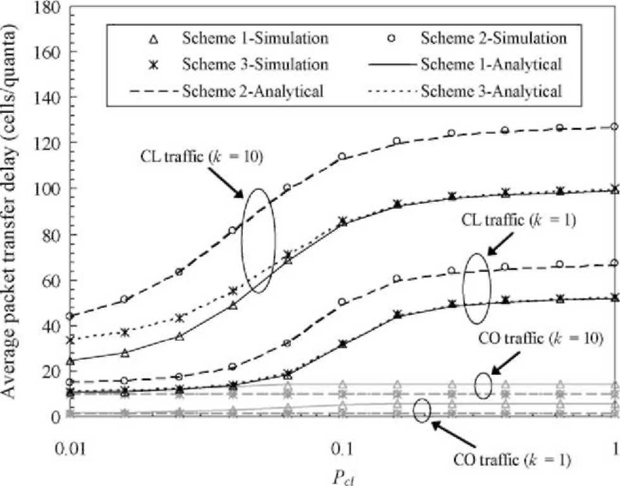
Fig. 5. Average packet transfer delay vs. Pcl.
(i.e. P_{cl})) is varied. When k = 1, the results for CL traffic under Schemes 1 and 3 are almost the same. Similar to the results when Pco is varied, the average CL packet transfer delay is relatively insensitive to a change in P_{cl} unless a threshold value of 0.1 is reached. The result shows that the threshold is about 1/m. Beyond the threshold value, the delay increases significantly towards a maximum value (about 67 under Scheme 2 and 53 under Schemes 1 and 3, in this example). This is because the arrival rate of CL cells/quanta is larger than the processing rate at the node (i.e. P_{cl}X m>1). As compared to the variation in P_{co}, the CL packet loss ratio is more sensitive to a variation in P_{cl}. However, the average CL packet transfer delay is less sensitive to a variation in P_{cl}.
The average CO packet transfer delays under Schemes 2 and 3 have a constant value of one, as explained earlier. When P_{cl} increases, the average CO packet transfer delay under Scheme 1 increases at a greater rate to 5.5 (i.e. in comparison with the result when P_{co} increases). It can easily
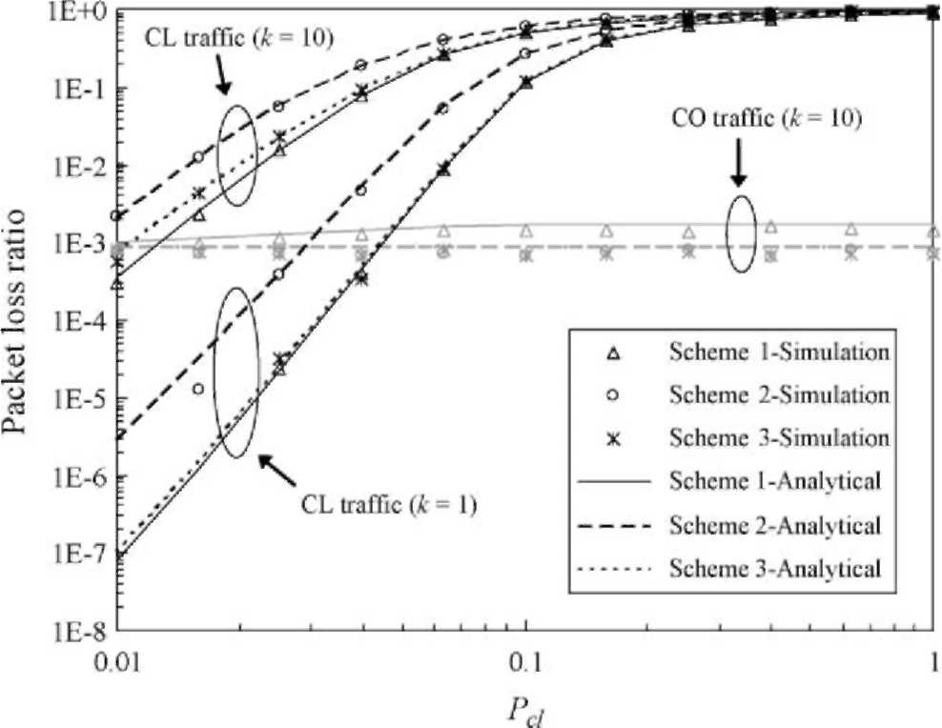
Fig. 6. Packet loss ratio vs. P_{cl}.
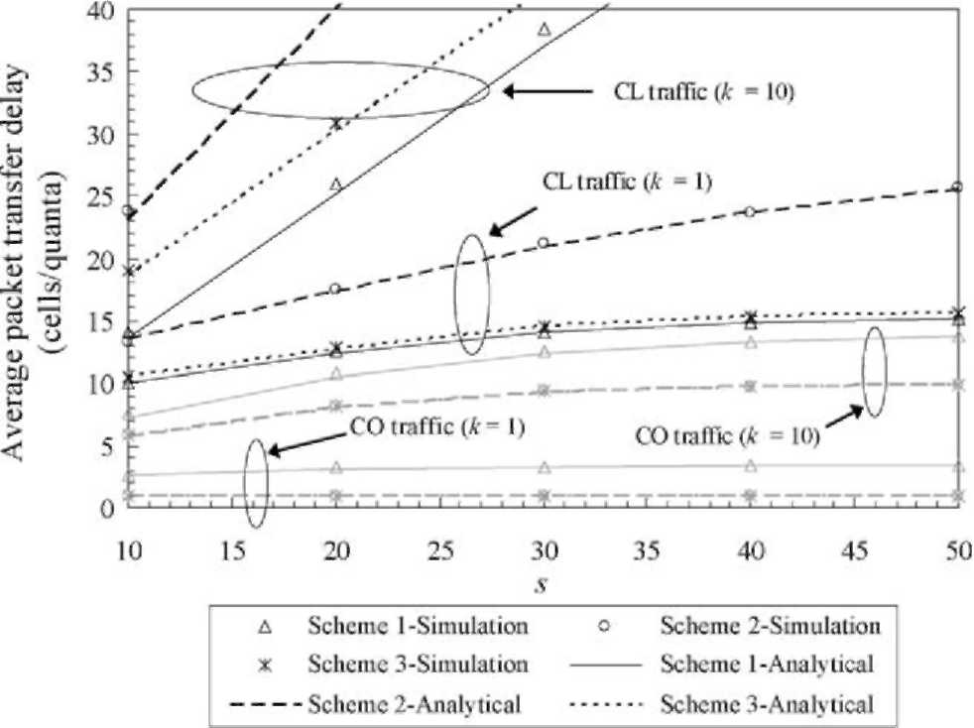
Fig. 7. Average packet transfer delay vs. s.
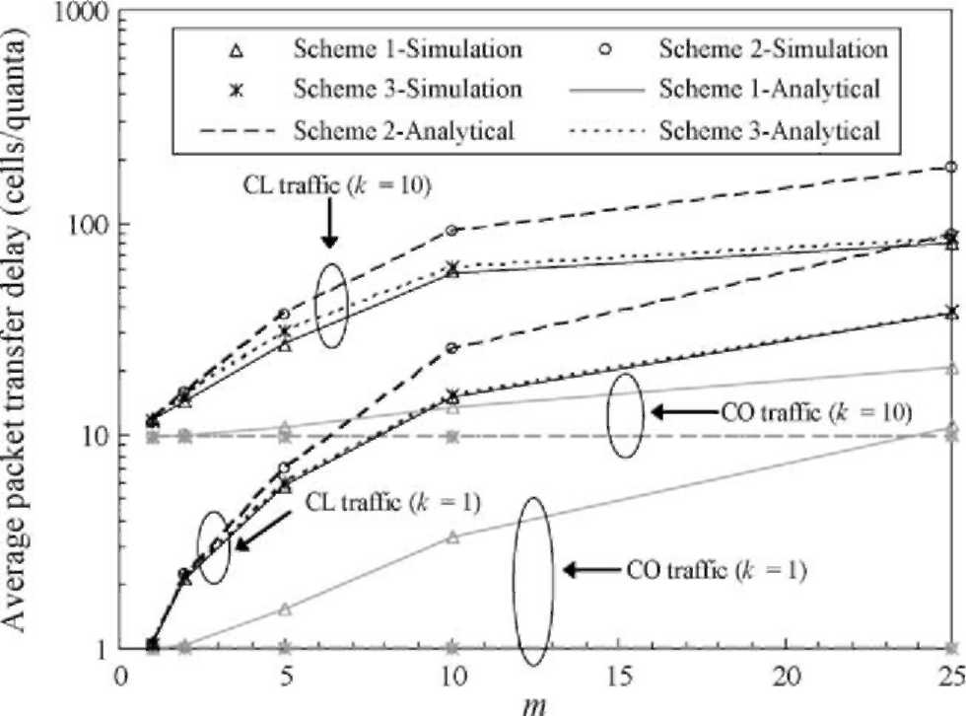
Fig. 9. Average packet transfer delay vs. m.
be shown that unless P_{co} is one, the maximum average delay is (1 + 2 + 3+ ... + 10)/10 = 5.5 because each value for the delay has an equal chance of occurring. This means that the time that a CO packet is required to wait for a CL packet to complete the current transmission ranges from 0 to 9 cells/quanta (or time units). We need to consider the CO packet transmission time as well. As shown in Figs. 5 and 6, the results for k= 10 are similar, in general, except that the average CL packet transfer delay, average CO packet transfer delay, and CL packet loss ratio are larger due to the larger CO packet arrival rate. The results (CO packet loss ratios) for the three schemes are zero when k= 1. When k= 10, the CO packet loss ratios under Schemes 2 and 3 remain constant at about 0.001, irrespective of the value of P_{cl}. Under Scheme 1, the CO packet loss ratio increases to a maximum value of about 0.0016 when P_{cl} increases.
Figs. 7 and 8 show, respectively, the average packet transfer delays and the packet loss ratios when the buffer size (i.e. s) is varied while P_{co}= 0.05 and P_{cl}= 0.05 are maintained. When k is small, the average CL packet transfer delays under Schemes 1 and 3 are almost the same and they are relatively insensitive to a variation in s. Under Scheme 2, the average CL packet transfer delay increases more significantly as s increases. The reverse is seen for the CL packet loss ratio. Under Schemes 1 and 3, the CL packet loss ratios decrease dramatically when s increases, whereas the CL packet loss ratio for Scheme 2 is less affected by a change in s. When k is larger, the average CL packet transfer delay increases more rapidly as s increases. However, the CL packet loss ratio shows a gentler decline.
Again, the average CO packet transfer delays under Schemes 2 and 3 maintain a constant value of one, due to the preemptive strategy, when k= 1. Under Scheme 1, the average CO packet transfer delay increases to a constant value of around 3.3 as the size of the buffer increases. The CO packet loss ratios for the three schemes are always zero, as explained earlier. When k= 10, the average CO packet transfer delay under Scheme 1 and Schemes 2 or 3 increases to maximum values of around 13.7 and 9.9, respectively, as
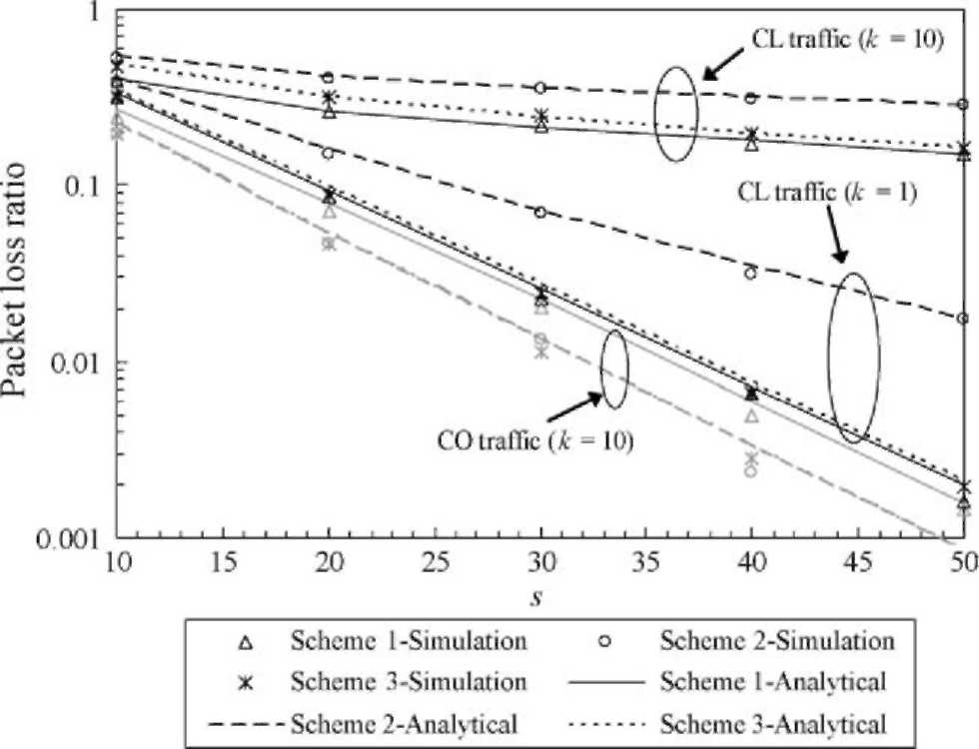
Fig. 8. Packet loss ratio vs. s.
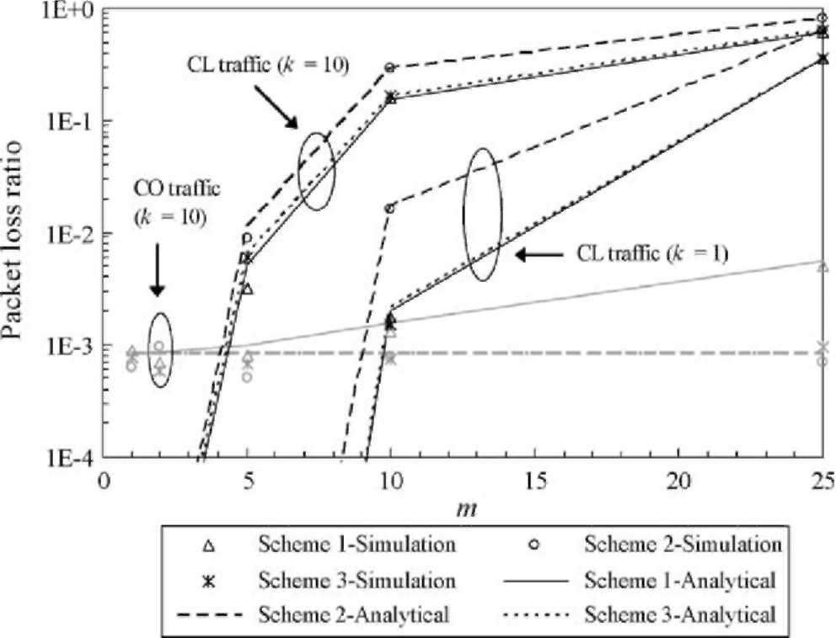
Fig. 10. Packet loss ratio vs. m.
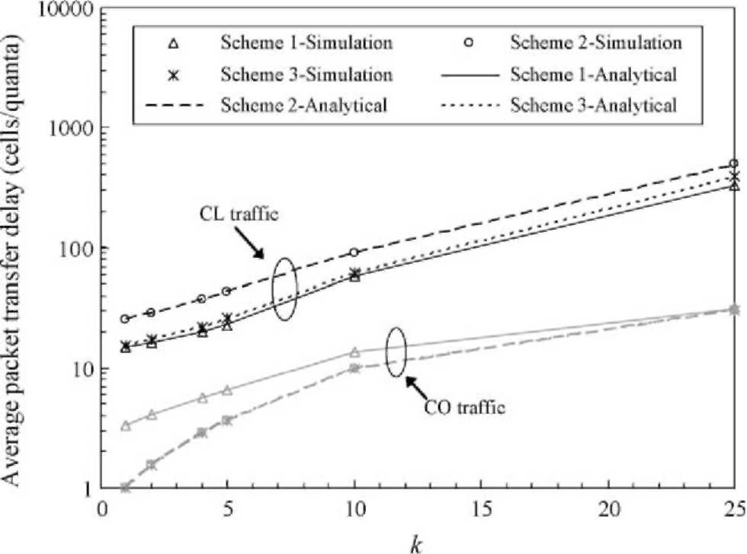
Fig. 11. Average packet transfer delay vs. k.
s increases. However, the CO packet loss ratios for the three schemes decrease when the size of the buffer increases.
Figs. 9 and 10 show, respectively, the average packet transfer delays and the packet loss ratios when the CL packet size (i.e. m) is varied. The average CL packet transfer delays and CL packet loss ratios under Schemes 1 and 3 are close and are lower than those for Scheme 2. The figures also show that the average CO packet transfer delay under Scheme 1 rises as m increases. However, the average CO packet transfer delays for the other schemes are maintained at a constant value of k. As expected, when k= 1, the CO packet loss ratios for the three schemes are 0. However, when k= 10, the CO packet loss ratio for Scheme 1 rises as m increases, whereas the results for the other two schemes remain constant because of their preemptive capabilities.
Figs. 11 and 12 show, respectively, the average packet transfer delays and the packet loss ratios when k is varied. The average CL packet transfer delays under Scheme 2 and Scheme 1 are, respectively, the most and least sensitive to an increase in k. However, the reverse is seen for the CL
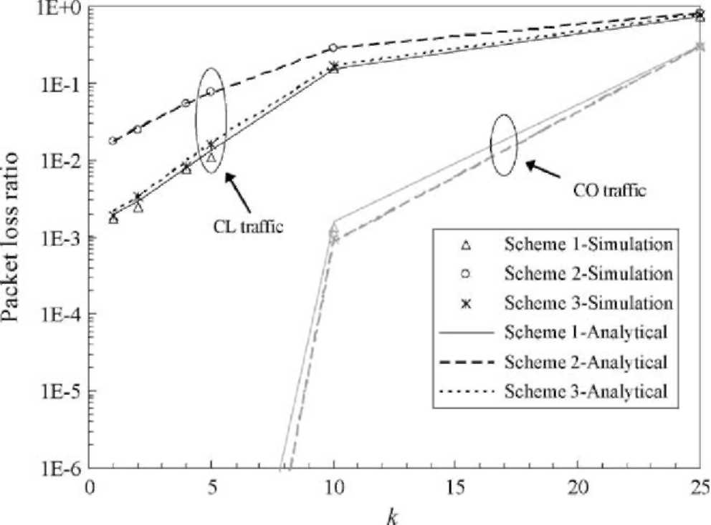
Fig. 12. Packet loss ratio vs. k.
Table 2
Summary of the analysis
Increase in Scheme 1 | Scheme 2 | Scheme 3
Effect on the average CL packet transfer delay | and CL packet loss ratio
Pco [ 1([ 1) | t 2(t 2) | t 1(t 1)
Pcl [ 1([ 1) | t 2(t 3) | t 1(t 2)
k [1 | t3 | t2
m [ 1([1) | t 2(t 3) | t 1(t 2)
Effect on the average CO packet transfer delay
Pco t2(t2) | = 1(t 1) | = 1(t 1)
Pcl t2([2) | = 1(= 1) | = 1(= 1)
k t 2 | t1 | t1
m t 2(t 2) | = 1(= 1) | = 1(= 1)
Effect on the CO packet loss ratio
^{P}co ⁼ ^{1(t} ²⁾ | = 1(t 1) | = 1(t 1)
Pcl = 1(t 2) | = 1(= 1) | = 1(= 1)
k t 2 | t1 | t1
m = 1(t 2) | = 1(= 1) | = 1(= 1)
Key: [: increase the value y: decrease the value =: no effect on the value. The numbers rank the values, where '2' indicates a greater value. Symbols outside and inside brackets correspond to k= 1 and k= 10, respectively.
packet loss ratios. Also, the results under Schemes 1 and 3 are comparable when k is small (i.e. below 10). Similar to the results for CL packets, the transfer delay and loss ratio for CO traffic increase when k is larger. However, the effect is less pronounced than that for CL traffic. It can be seen that Scheme 1 has a larger average CO packet transfer delay and CO packet loss ratio than Schemes 2 and 3.
We note that the simulation results and analytical results match very well in Figs. 3-12. Table 2 summarizes the effects that the traffic parameters have on performance. In general, the CO traffic parameters (i.e., P_{co} and k) produce a more significant effect on performance than the CL traffic parameters (i.e. P_{cl} and m). In summary, Scheme 2 is not preferred for CL traffic because both the average CL packet transfer delay and the CL packet loss ratio are the highest and the most sensitive to changes in the parameters among the three schemes. Scheme 1 is not preferred for CO traffic because CO packets suffer from a longer delay, especially if the CL packet is large. The above analysis confirms the advantage of using Scheme 3 for multiplexing CL and CO traffic. Scheme 3 produces a balanced performance for CL and CO traffic while ensuring that time-sensitive CO traffic can always be served at a higher priority.
5. Conclusions
We have presented the quantum packet method for both CL and CO traffic. Using a Markov model, we have also analyzed the performance of three schemes for integrating CL traffic and CO traffic. This Markov model has been validated by results from simulations. Analytical and simulation results, which match closely, have been presented as part of a study of the behavior of the system. In particular, we have conducted some sensitivity analyses by varying the system parameters in turn. Our results
indicate that the third scheme gives a balanced performance for both CL and CO traffic. Hence, it is the preferred method. However, the performance of the three schemes is reasonably close if the traffic load is low or moderate.
Acknowledgements
The work described in this paper has been supported by a grant from the Research Grants Council of the Hong Kong Special Administrative Region, China, under account
number PolyU 5085/00E.
References
[1] D.E. McDysan, D.L. Spohn, ATM Theory and Application, signature
edition, McGraw Hill, New York, 1998. [2] L.L. Peterson, B.S. Davie, Computer Networks: a Systems Approach,
3rd ed, Morgan Kaufmann, Los Altos, 2003. [3] W.R. Stevens, first ed TCP/IP illustrated, vol. 1, Addison Wesley,
Reading, MA, 1994. [4] C.T. Lea, C.Y. Tsui, B. Li, L.C.Y. Kwan, S.K.M. Chan, A.H.W. Chan,
A/I Net: a network that integrates ATM and IP, IEEE Network 13(1)
(1999) 48-55.
[5] I. Andrikopoulos, G. Pavlou, P. Georgatsos, N. Karatzas, K. Kavidopoulos, J. Rothig, S. Schaller, D. Ooms, P. Van Heuven, Experiments and enhancements for IP and ATM integration: the IthACI project, IEEE Communications Magazine 39 (5) (2001)
146-155.
[6] U. Black, Emerging Communications Technologies, second ed,
Prentice-Hall, New York, 1997. [7] P. Loshin, Essential ATM Standards: RFCs and Protocols Made Practical, Wiley, Englewood Cliffs, NJ, 2000.
[8] M.R. Karim, ATM Technology and Services Delivery, first ed,
Prentice-Hall, Englewood Cliffs, NJ, 2000. [9] B. Davie, P. Doolan, Y. Rekhter, Switching in IP Networks: IP
Switching, Tag Switching, and Related Technologies, first ed, Morgan Kaufmann, Los Altos, 1998.
[10] H.M. Ahmed, R. Gallon, A.G. Malis, J. Moy, IP switching for scalable IP services, Proceedings of the IEEE 85 (12) (1997) 1984-1997.
[11] Y. Rekhter, B. Davie, E. Rosen, G. Swallow, D. Farinacci, D. Katz, Tag switching architecture overview, Proceedings of the IEEE 85 (12) (1997)1973-1983.
[12] A. Viswanathan, N. Feldman, Z. Wang, R. Callon, Evolution of multiprotocol label switching, IEEE Communications Magazine 36 (5) (1998) 165-173.
[13] G. Armitage, MPLS: the magic behind the myths, IEEE Communications Magazine 38 (1) (2000) 124-131.
[14] R. Bayou, P.T. de Sousa, M.F. Roy, European trials: from ATM to IP, in: Proceedings of the First IEEE/Popov Workshop on Internet Technologies and Services, Moscow, Russia, October 1999, pp. 4450.
[15] P. Dumortier, Toward a new IP over ATM routing paradigm, IEEE
Communications Magazine 36 (1) (1998) 82-86.
[16] B. Sales, P. Van Mieghem, Dual-mode routing: a generic framework for IP over ATM integrated routing, in: Proceedings of the Third IEEE Symposium on Computers and Communications (ISCC'98), Athens,
Greece, June-July 1998, pp. 326-330.
[17] R.Y.W. Lam, Quantum Packet for Integrated Services Data Network—The Third Generation ISDN, MPhil Thesis, Department of Computing, The Hong Kong Polytechnic University, 2003.
[18] D. Grossman, J. Heinanen, Multiprotocol Encapsulation over ATM
Adaptation Layer 5, IETF RFC 2684, September 1999.
[19] J.M. Pitts, J.A. Schormans, Introduction to IP and ATM design and
performance, second ed, Wiley, New York, 2000. [20] L.G. Dron, G. Ramamurthy, B. Sengupta, Delay analysis of
continuous bit rate traffic over an ATM network, IEEE Journal on
Selected Areas in Communications 9 (3) (1991) 402-407. [21] H.M. Taylor, S. Karlin, An Introduction to Stochastic Modeling, third
ed, Academic Press, New York, 1998.

